TRANSPERSONAL

THERAPIST TRAINING
  - Course Programme
  - Dunderry Park, Co. Meath

  - INTRODUCTION, MODULE BREAKDOWN AND FAQ’S

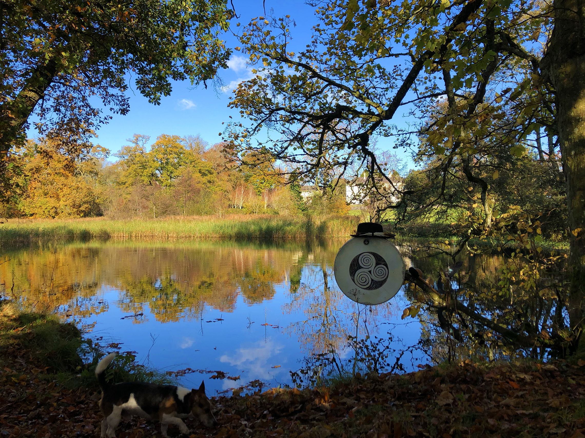

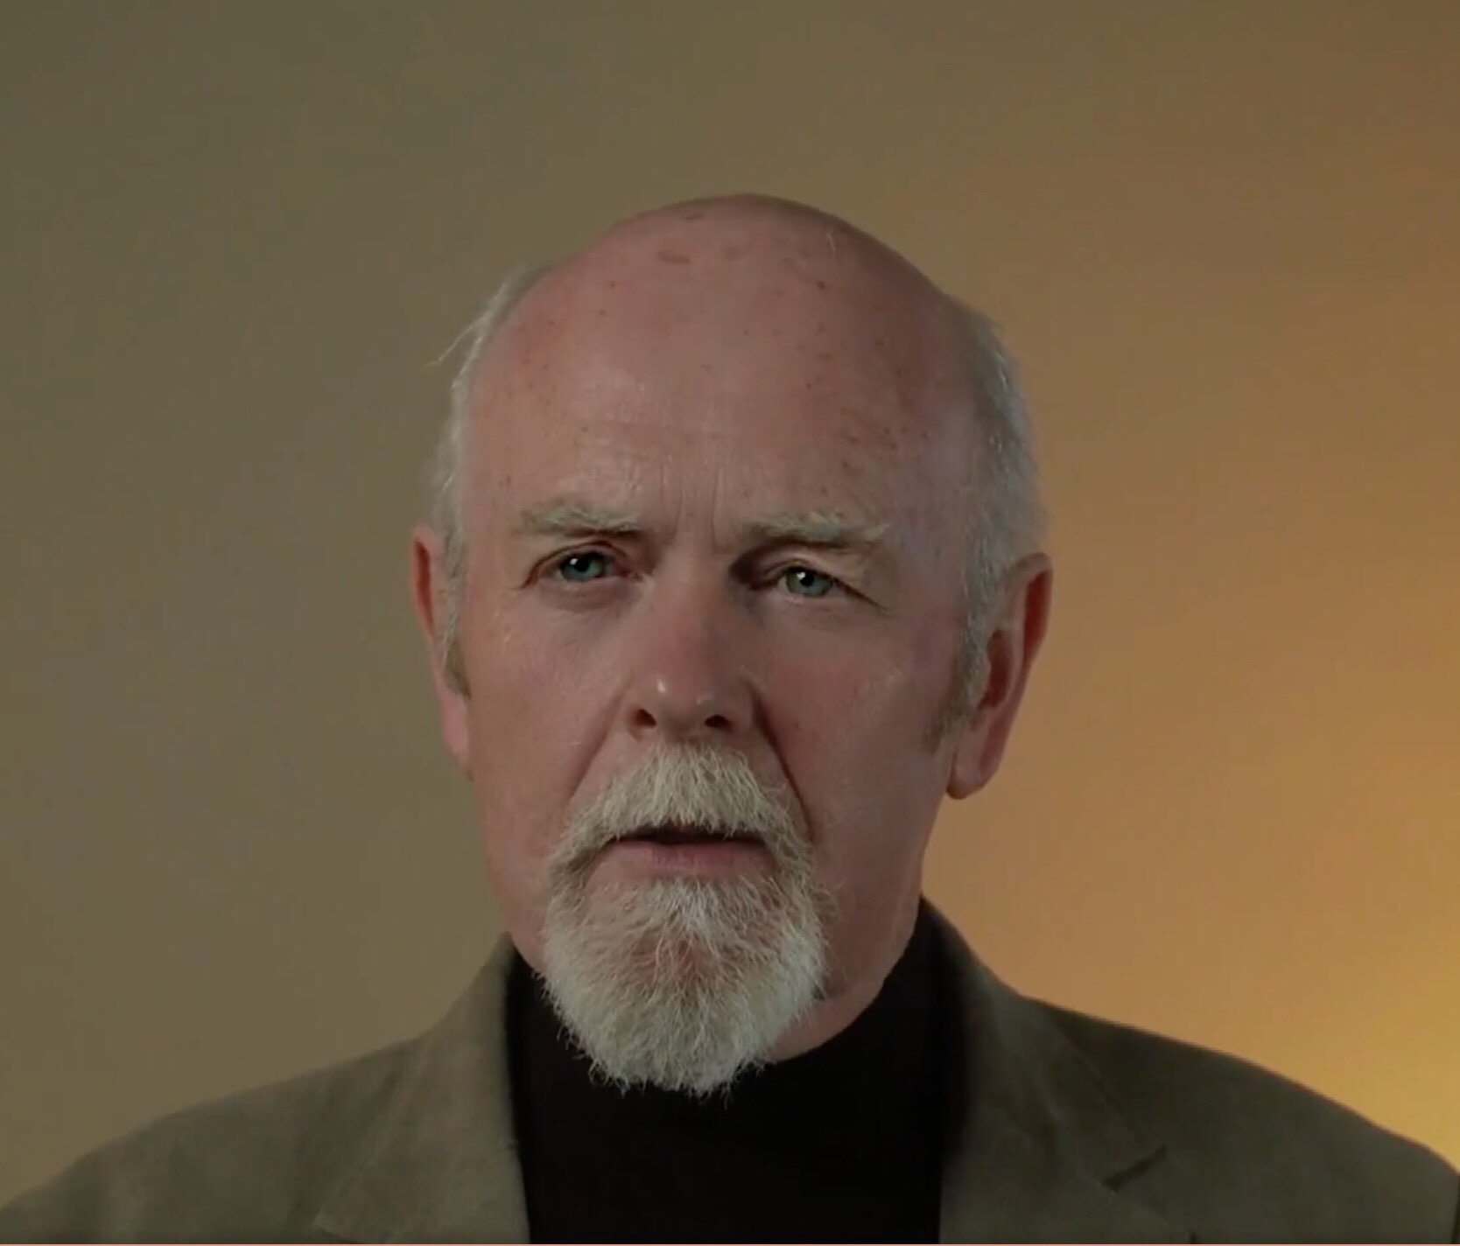 | MARTIN DUFFY  MIAHIP, EAP, CMHN  Transpersonal Psychotherapist  and Shamanic Teacher.
Martin Duffy is the director of the Oaktree Charitable Trust, a non-profit organisation that runs the Irish Centre for Shamanic Studies at Dunderry Park. Martin has worked as a mental healthcare professional since 1977. He is an accredited Transpersonal /Jungian Psychotherapist. He has trained in various forms of consciousness shifting methods including Holotropic Breathwork with Stanislav Grof, Dreamwork, Trance Dancing, and Firewalking. His grandfather and mother were traditional folk healers, and he is following in their footsteps. Martin’s work is influenced by the Druidic traditions of ancient Ireland. He has done fieldwork with indigenous Shamans from Mongolia, the Amazon, Andes, and Africa and has trained in core Shamanism with the Foundation of Shamanic Studies (USA) and the Scandinavian Centre for Shamanic Studies. Martin brings warmth and compassion to his shamanic practice. He has strong values with regards integrity, honesty, and openness, he believes in empowering the individual to find healing, knowledge, and wisdom within themselves. Martin is available for one-to-one sessions for Transpersonal Psychotherapy, Soul Retrieval, Shamanic Counselling and Healing.

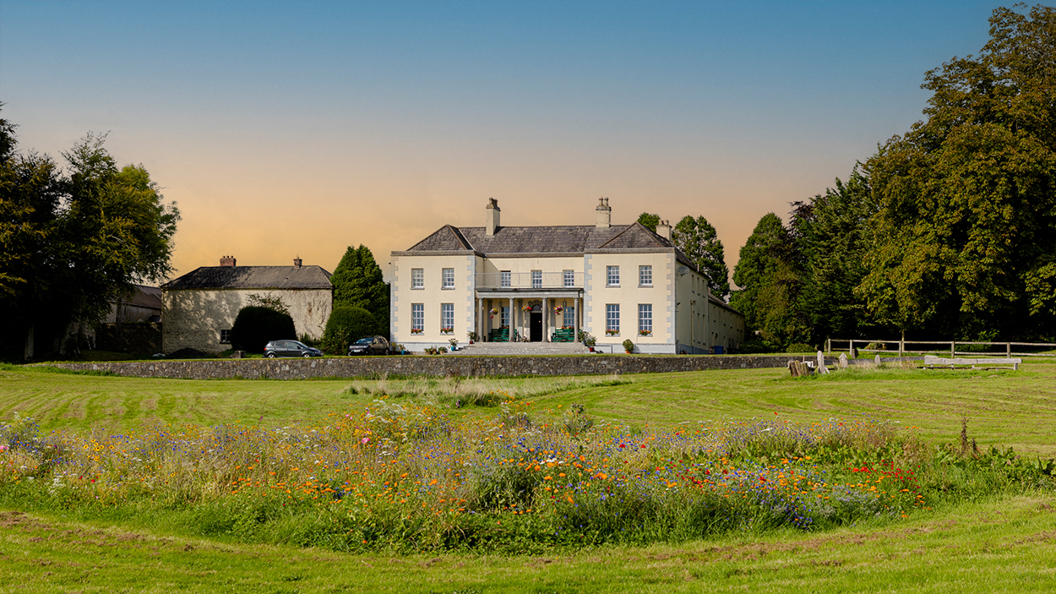

What is Transpersonal Psychology?

The term Transpersonal means beyond the personal. It is a form of spiritual psychology which studies human experiences beyond the realms of ordinary reality. This includes methods such as Shamanic Holotropic Breathwork, Dreamwork, Meditation, Journeying, Yoga, Reiki, Trance States, Shamanism, Mystical and Peak Experiences, Ecology, Non-Ordinary States of Awareness and Consciousness Studies. According to Lajoie and Shapiro (1992) Transpersonal Psychology is concerned with humanity’s highest potential, and with the recognition, understanding, and realisation of unitive, spiritual, and transcendent states of consciousness. At the Irish Centre for Shamanic and Transpersonal studies, we believe that an experiential and holistic approach to understanding Transpersonal Psychology is vital. We strive to combine the spiritual with the practical and theoretical, so that participants can have access to a direct experiential and theoretical understanding of
the spiritual realms.

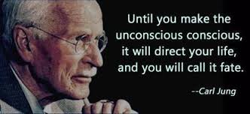

What does the Transpersonal Therapist Training Involve?

This training is modular in nature, participants can begin the course at any point as credits will be awarded for each module completed leading to a final certificate of accreditation as a Transpersonal Therapist when the required number of credits have been obtained (1000 credits). These credits will also be given for past courses completed through The Irish Centre for Shamanic and Transpersonal Studies.

How is the Transpersonal Therapist Training Accredited?

The course is accredited by the Irish Centre for Shamanic and Transpersonal Studies, in the same manner as the Shamanic Practitioners Training. The training allows those who have undertaken some Shamanic and Transpersonal studies to deepen their theoretical knowledge and gain accreditation as a Transpersonal
Therapist. It also allows those with no previous experience an opportunity to train in Shamanic and Transpersonal theory and practices.

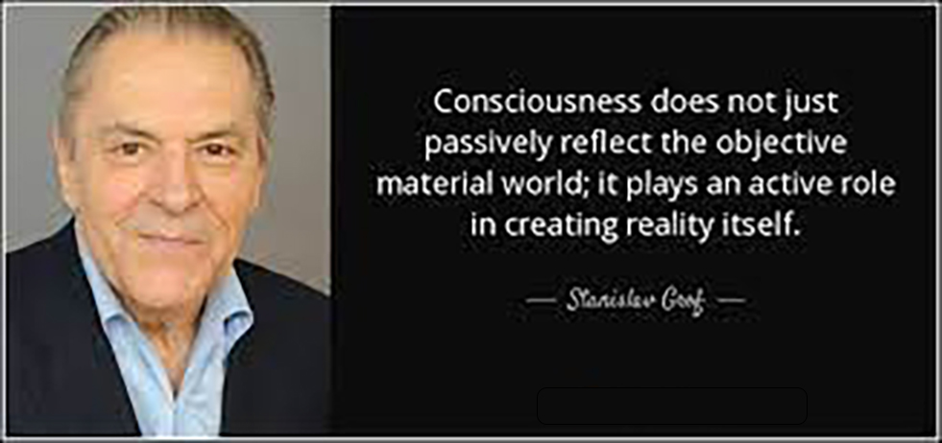

What is Holotropic Breathwork TM?
Holotropic Breathwork™ was created by Dr. Stanislav Grof and Christina Grof as a method to journey deeper into the non-ordinary realms of consciousness, using deep and fast breathing, powerful evocative trance music and healing bodywork. Shamans and mystics have used the breath to access the healing potential of
non -ordinary reality for thousands of years.

Holotropic Breathwork™ leads one into an adventure of self-discovery,
self-exploration, and self-healing. Participants have access to deep shamanic journeys, past life memories, merging with the cosmic mind, ecstatic and joyful experiences, and mystical awareness states. Other experiences may include re-experiencing birth, release of energetic blockages caused by past traumas, and the healing of emotional and physical conditions.

This workshop takes place within a safe and sacred setting. Participants work in pairs, while one breathes the other sits and supports their journey. The Breathwork experience is also supported by group work and art therapy. The sessions typically last around three hours, giving adequate time to journey as deeply as you need to go. Other activities will include Shamanic Journey, time in nature, trance dancing and group sharing. Shamanic Holotropic Breathwork is part of the personal development work and training on the Transpersonal Therapist Training.

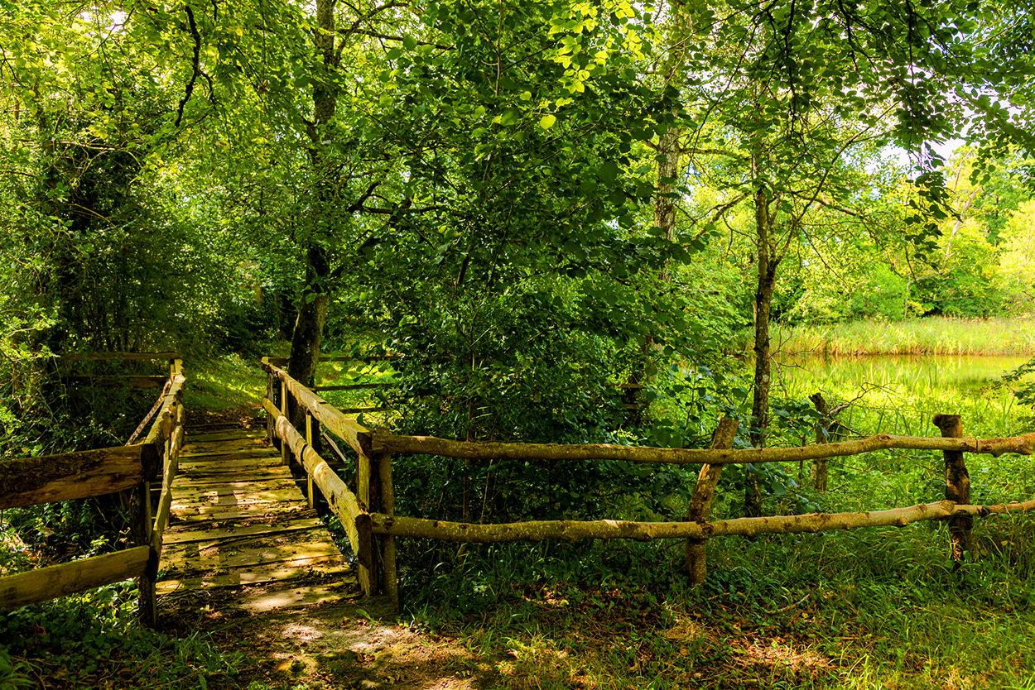

Who can take part in this course?

Anybody with an interest in Shamanism or Transpersonal Psychology can take part in this training. In the past, we have had a wide variety of practitioners and non-practitioners complete our training. This includes Psychotherapists, Counsellors, Yoga teachers, Artists, Holistic Practitioners, Medical Nurses, and Doctors as well as people who previously did not practice in any discipline.
Indeed, during the training, we will explore in depth the archetype of ‘The Wounded Healer’, and ‘The Way of the Wound’. This essentially means that Healers and Therapists who have journeyed to the depths of their own ‘woundedness’ to find healing for themselves, are better able to guide others to find their own healing. We are not interested in any group more than another and encourage anyone with an interest in the Transpersonal perspective to take part.

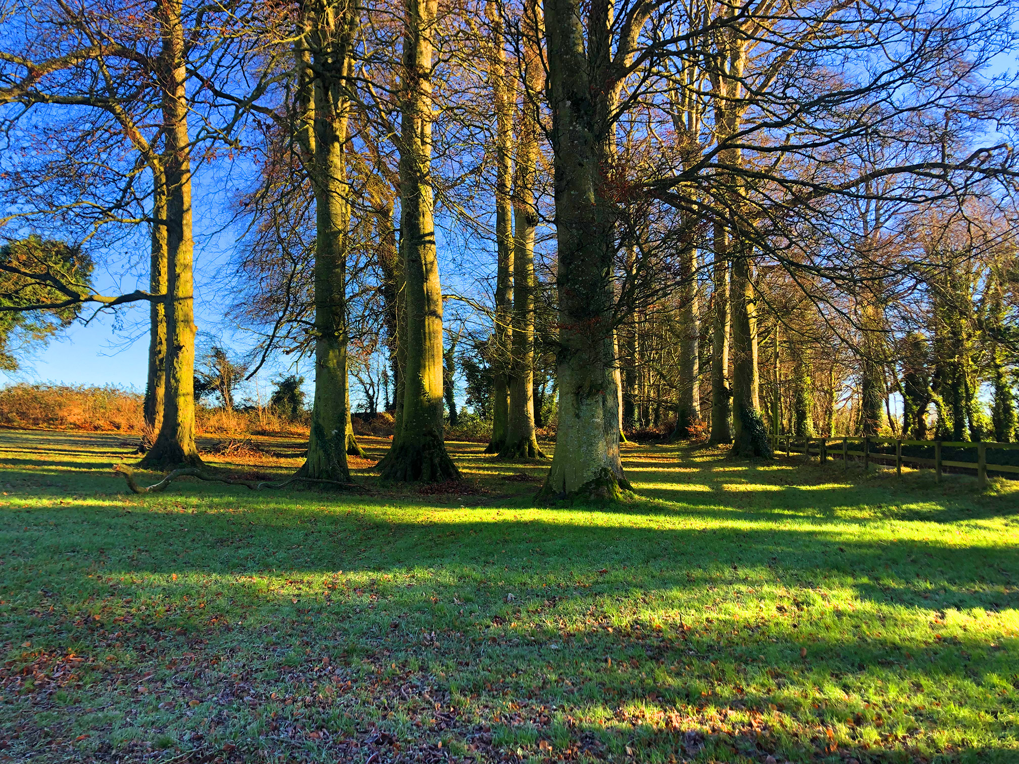

How much will this training cost?
As the course is provided on a modular basis, there is no one off cost, as fees will be payable per module. The total cost will depend on which modules of the Transpersonal Training you choose to partake in. The costs for all in-person and online trainings are available on our website- www.shamanismireland.com. You can book workshops directly through the website, and these will be added to your accumulated credits upon attendance. Once you attend any in-person training, or book any of our online courses, or attend our webinars, you are automatically enrolled in the Transpersonal Therapist Training.

How do I register for the Transpersonal Therapist Training?
You register for the Transpersonal Therapist Training by attending any of our in-person training courses listed below or any of our online modules or webinars.
You can book workshops directly through the website, and these will be added to your accumulated credits upon attendance.
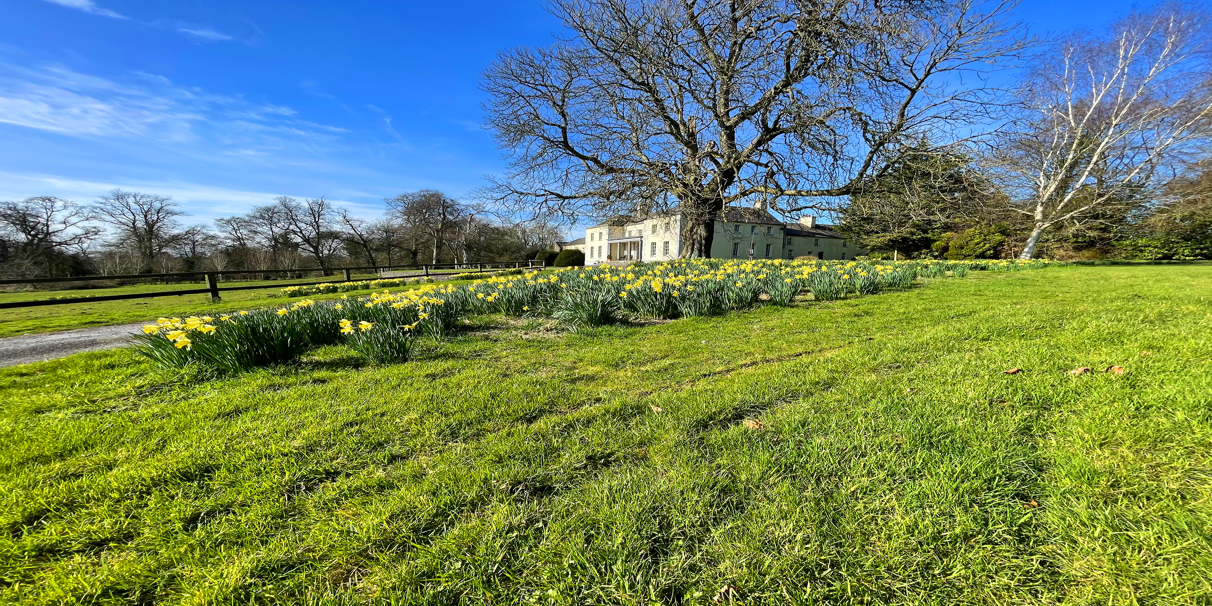

What is the module breakdown?

The total number of credits needed for certification is 1000 credits.

Live, In-person Training at Dunderry Park.
(Dates/booking details for courses listed below on website www.shamanismireland.com)
The Shaman’s Journey:100 credits
Shamanic Practitioner Training-300 credits
Shamanic Counselling. 200 credits
Earth Sea and Sky Woman-50 credits

Advanced Shamanic Training
Shamanic Holotropic Breathwork-150 credits. (Dates to be announced)
Webinars-50 credits (Dates to be announced)
Transpersonal Therapist Training Days-100 credits (Dates to be announced)

Transpersonal Training Online Modules (Booking details on www.shamanismireland.com)
The Elements of Shamanism: 100 credits
The Journey Home-Playing the Cosmic Game: 150 credits
Spiritual Emergence/Emergency: 50 credits
Past Life Regression: 50 credits
Past Transpersonal Therapist Training Days
Jungian and Transpersonal Psychology 100 credits
Past Life Regression 100 credits
Spiritual Emergence/Emergency 100 credits
Dreamwork, Imagery and Visualisation-100 credits

We will continue to provide new modules/gatherings and online training and advanced training webinars taking a more in-depth deeper dive into what was covered on the online training modules and the in-person training.

Once you have accrued 1000 credits, please email info@shamanismireland.com and we will post your certificate to you.

Module Breakdown Summary

To complete the training, participants must gain 1,000 credits in total. Each course you attend at Dunderry Park in-person or any of our online modules, webinars, or Advanced Training modules accrues credits towards certification. The flexible nature of the modules means that participants can choose how you want to amass the credits you need to receive certification. Participants who have already completed workshops, will have these credits calculated and put towards their ﬁnal accreditation. There is no set timeline for completing any of the modules, and participants can set their own learning and schedules and choose which modules you wish to attend. Once you have 1000 credits email info@shamanismireland.com and we will post your certificate as a Transpersonal Therapist to you.

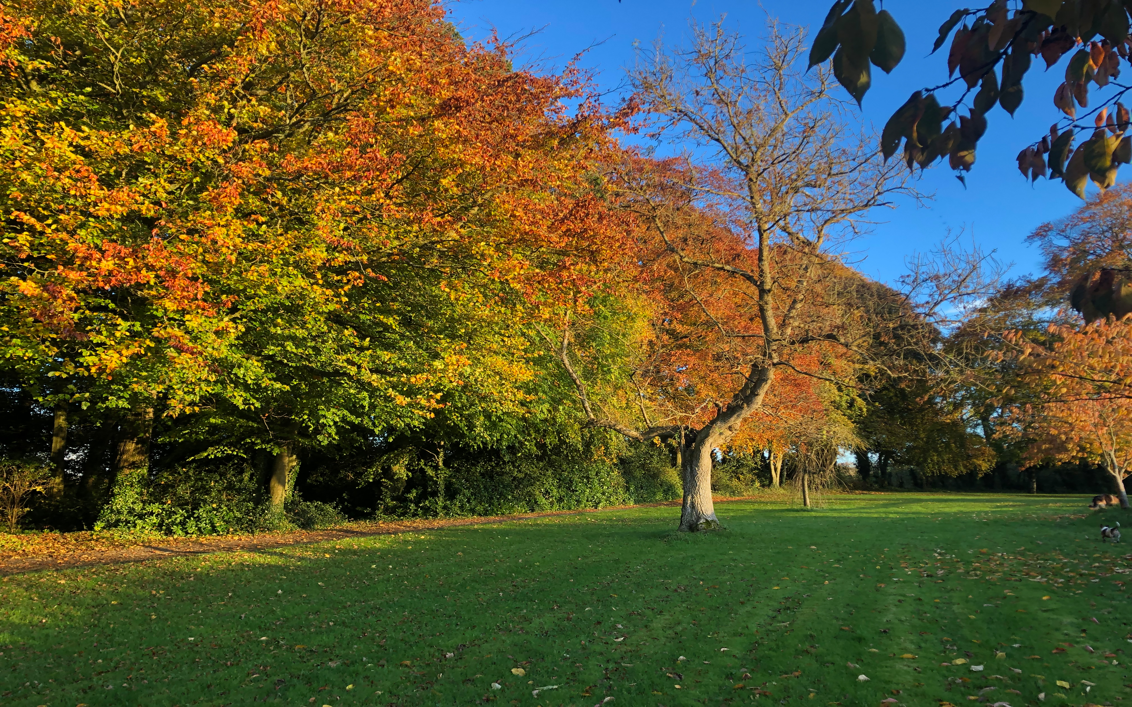

What about past courses I have attended?
If you have already completed any of the courses above, these credits will be automatically awarded to you, and you will not be required to attend the courses again.

Who is facilitating this course?
The course is being organised and facilitated by Martin Duﬀy. (MIAHIP, EAP, CMHN) Martin has worked as a Mental Health Professional for 35 years with the HSE and is an accredited Humanistic & Transpersonal Psychotherapist, Shamanic Practitioner and Teacher.

Is there a sequence to the modules that must be followed?
No. We will work with you to accommodate your schedule and financial circumstances to ensure that you have a learning plan that works for you.

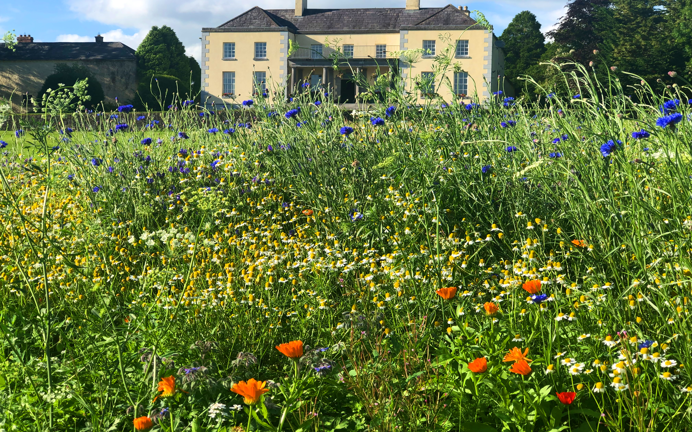

What is the teaching format?
The teaching format will be through attending in-person workshops, Lectures, Online Modules, Webinars, Group Work and Dialogue, and experiential methods such as Journeying, Dreamwork, Shamanic Holotropic Breathwork, Meditation, Past Life Regression.
As the course is provided on a modular basis, there is no one oﬀ cost, as fees will be payable per module or training you choose to attend. You can book workshops directly through the website, and these will be added to your accumulated credits upon attendance.

What are Shamanic Holotropic Breathwork Modules?
Shamanic Holotropic Breathwork modules will begin on a Friday evening at 8pm and continue until Sunday at 4pm. The Friday evening session will involve lectures on the theory and practice of Shamanic Holotropic Breathwork. On Saturday we will have two sessions of Breathwork, as sitter and breather. The music will have a Shamanic theme throughout the session. Also included will be mandala drawing and group integration work. Participants will need to have completed the Shamanic Practitioner Training with Martin Duffy to attend these modules and the online course ‘The Journey Home, Playing the Cosmic Game’.

Transpersonal Therapist Training
The term Transpersonal means beyond the personal. It is a form of spiritual psychology which studies human experiences beyond the realms of ordinary reality. This includes methods such as Shamanic Holotropic Breathwork, dreamwork, meditation, journeying, yoga, reiki, trance states, shamanism, mystical and peak experiences, ecology, non-ordinary states of awareness and consciousness studies. | 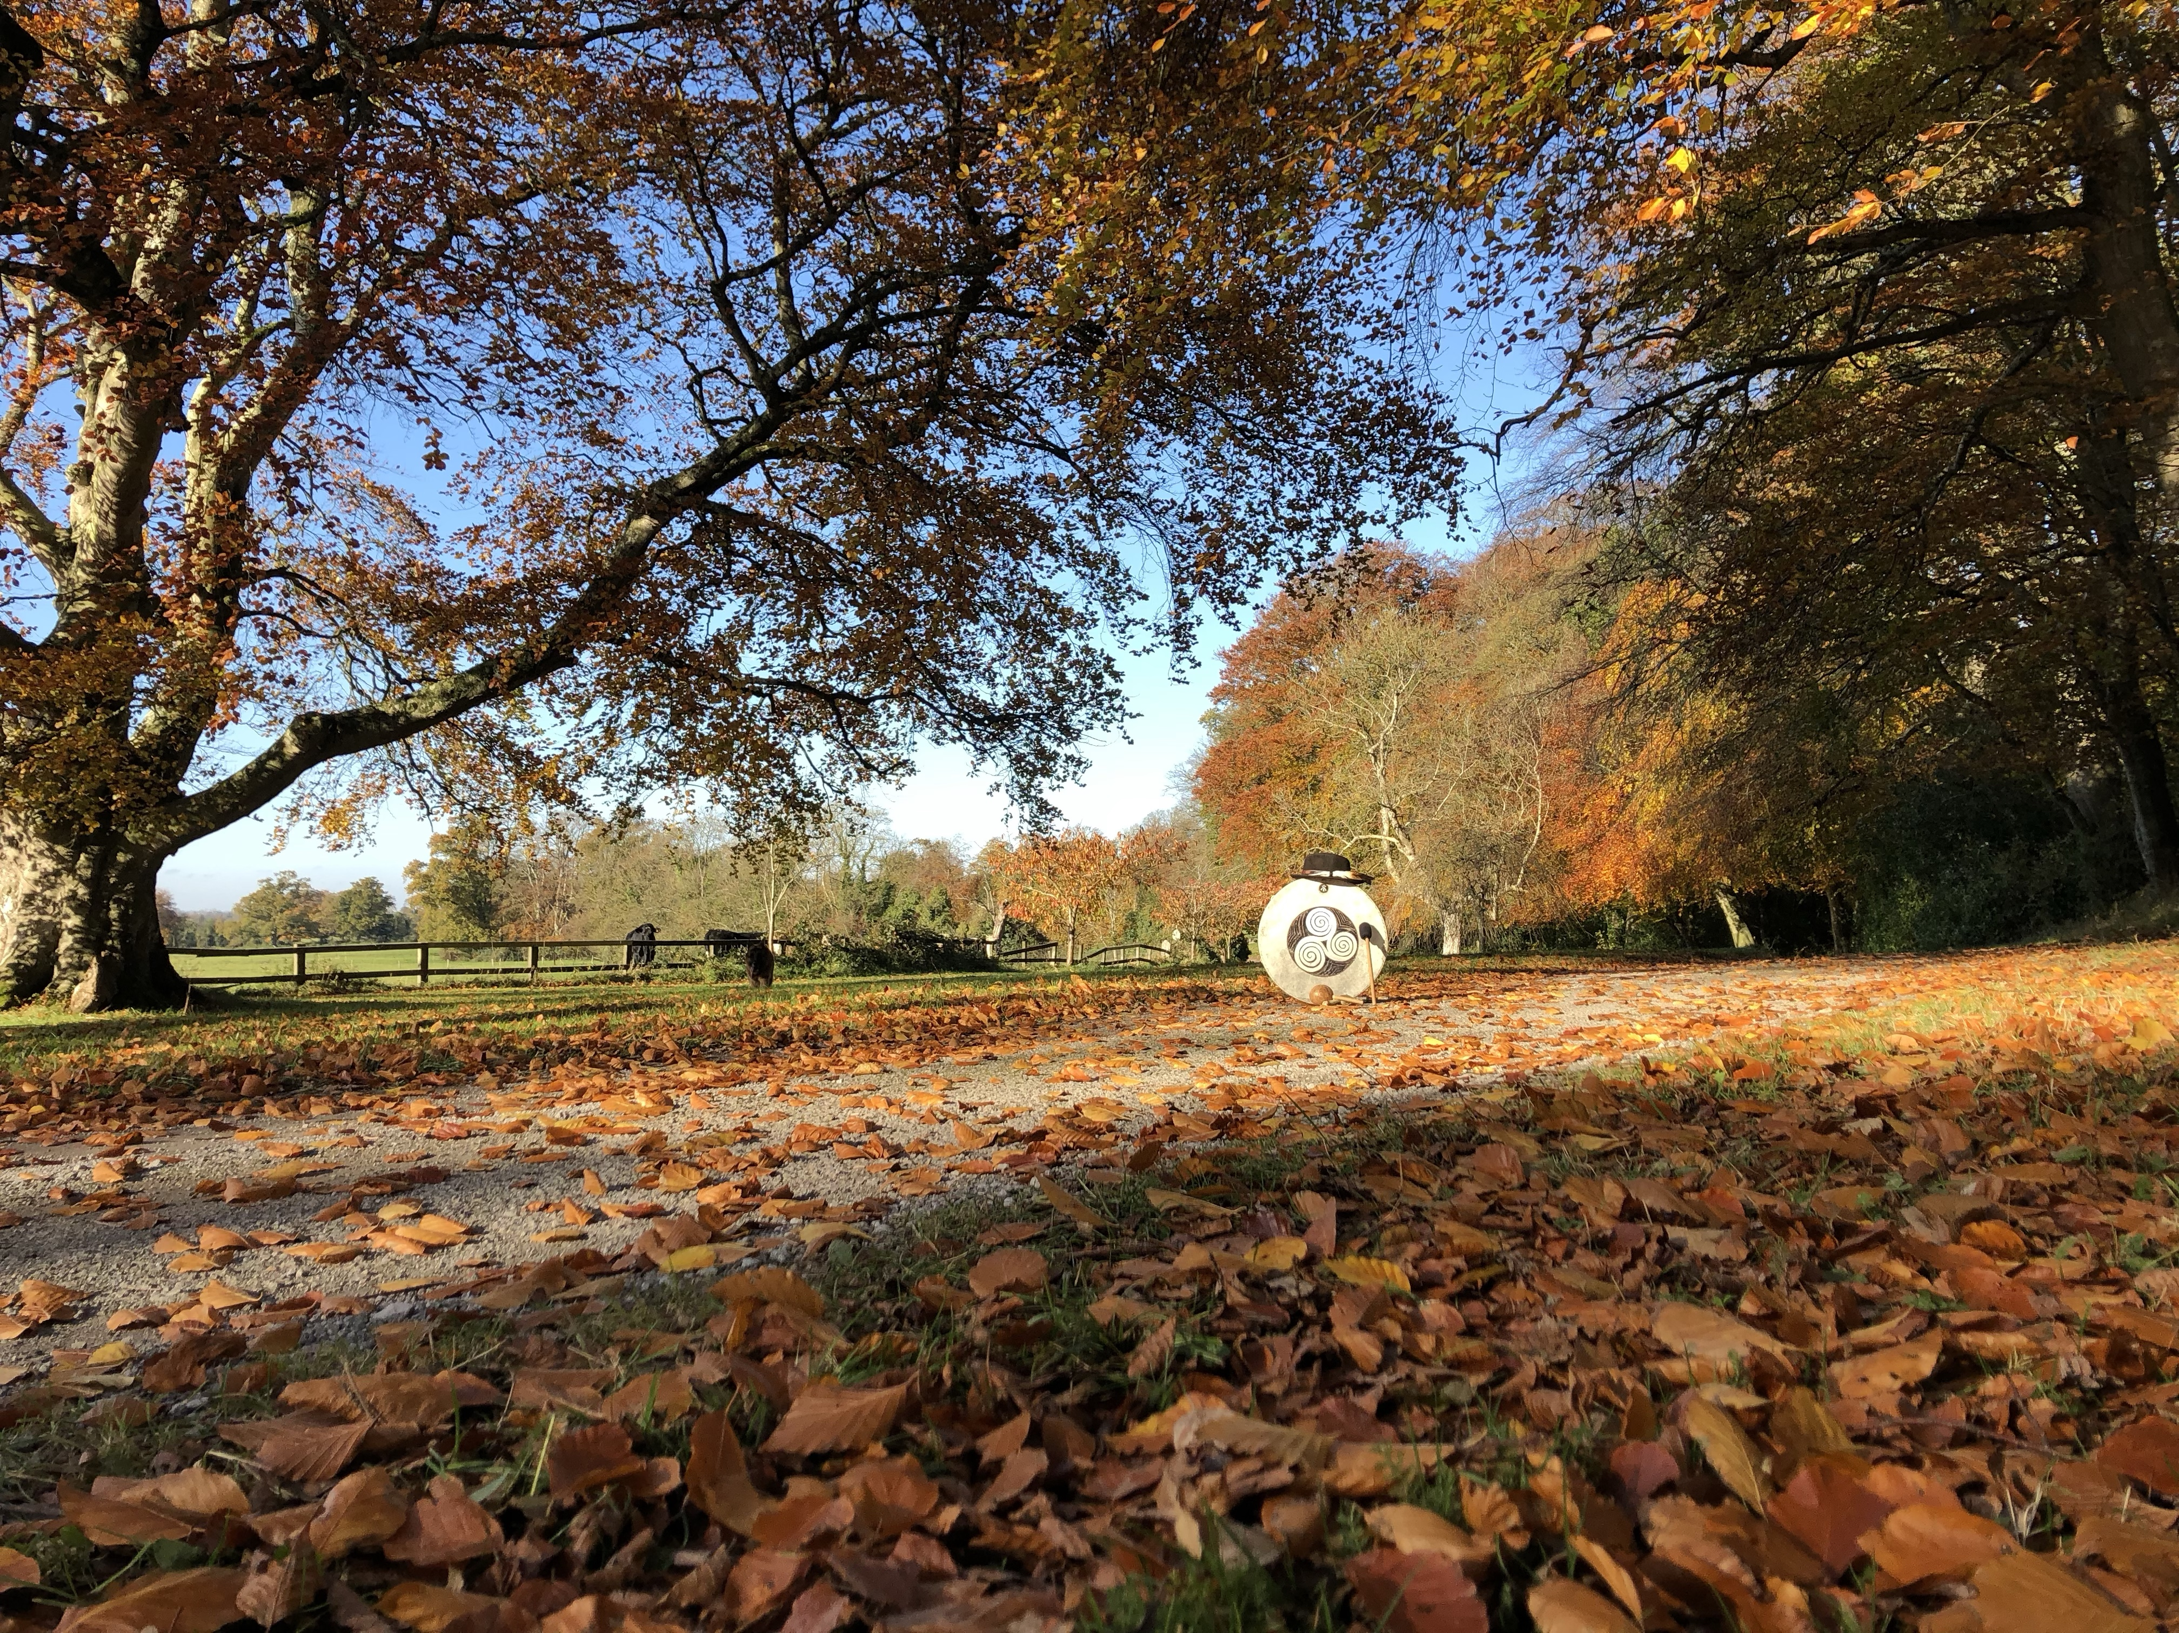
This training will be modular in nature, participants can begin the course at any point as credits will be awarded for each module completed leading to a final certificate of accreditation as a Transpersonal Therapist when the required number of credits have been obtained. These credits will also be given for past courses completed through The Transpersonal Institute and Irish Centre for Shamanic Studies. These include all in-person Training held at Dunderry Park, Online Training Courses, Webinars, Shamanic Holotropic Breathwork, and One day workshops. The teaching format will be through in-person attendance at any of our in-person training held at Dunderry Park, Lectures, Online Modules, Webinars, Group Work and Dialogue, and experiential methods such as Journeying, Dreamwork, Shamanic Holotropic Breathwork, Meditation, Past Life Regression.

To register for this Certificated Transpersonal Therapist Training visit our website on: www.shamanismireland.com and register for any of our online modules or sign up for any of our in-person training.

